​



Hmmmmm,
What if we use the TON to get cheap money from regular investors around the world
then lend this money in countries where the credit is expensive
like Brazil?

Hope you guys don't mind, the title was just a joke to be a little different from what I believe you guys receive every day. If somebody got offended, please, sorry.

I was going to write a business plan, but I don't think something like the TON project fits into something archaic, especially after seeing the gaming system; I decided to bet on this model. We might both miss a great opportunity, but the modern project is receiving a modern proposal. Shall we?
I met TON and fell in love, even though I'm not a gamer (for example, I don't have a single game on my mobile phone). When I saw what was possible, it kind of shook my world. But you guys know it, and I don't need to say it again.
I am working on a project (currently alone and financing everything with my own funds), so progress was slow, especially now when choosing the platform that would be the 'face' of the project, where users would find us. The positive point that sparked my interest in TON is that besides being mature already and still in constant development (not to mention the DNS system, which would greatly help in the project).
Without further ado, here I will mention the basics but explain them better in another paper with details.
Brazil is one of the countries that charges the highest interest rates in the world. Consignment loans (I don't know if they exist there, so I ask permission to explain; it's when the installment money is deducted directly from the payment of the wage earner, retiree, or anyone who receives some type of payment through banking channels. There are also loans that can be made through the electricity bill, and the installment comes with the bill, and the person is obliged to pay because they are 'mixed') thus, as safe as it may be for the lender, there are still very high-interest rates. A loan of $600 reais in 20 installments ends up becoming $1200 reais, something very high for the standards here.
My project is to create a platform where (for bureaucratic reasons) there would be 'boxes,' and people would invest in these boxes as much as they wanted. However, as a smart contract, they should wait for the time to withdraw the funds.
Once the box closes, that is, reaches the limit, it is no longer possible to invest more, and whoever invested ends up with a wallet that would be like a title; they can sell, keep, do whatever they want, but it will be in this wallet that they will receive their dividends at the end of each year. The main term is one year, but in rare occasions, it can extend to two.
When it arrives in Brazil (and here is where we start spreading TON around the world), I will sell it in partner brokers, and it will become fiat and then be used for consignment loans. Safe, sure to be paid, and no headaches (in case of the person's death, the debt is paid in full).
I don't know if there are validators in Brazil, but whether there are or not, I already plan to first present the brokers with TON and then use its own system, which allows a kind of domain, to sell the project to the hundreds of betting sites that are flooding Brazil; many would love to have 'their own money,' so to speak.
However, my main focus is my credit company, where I will be able to sell (even though initially it may not be so profitable because people will be getting to know the currency [people I refer to are brokers, traders]), still in a country with 35% interest rates per year on consignment loans, it is possible to pay all taxes and fees, lose a little to gain later (I mean, sell cheaper at first until popularization), and have a great profit by charging less than competitors, which will automatically make the company have a good reputation and word-of-mouth marketing, which is the best there is.
When the funds run out or need more, a new round is opened, and people can invest, and that is the cycle of the project, initially slow to popularize the currency among traders and my company among loan takers, and then accelerate like any company.
The initial investment would be to keep the company for a year (one IT person [who would have a more security-focused role], I would take care of sales and negotiation, presenting the token to brokers and traders, one person for support/sales whom I would train, and finally building the bot with the smart contract system on Telegram because that way we reach more people and work seriously and focused, in 8 months we already start paying our own bills, and yes, I made this calculation when I thought about an IDO, but I mentioned 12 because a portion will be kept as insurance in case of a very strong fluctuation. Of course, we cannot prevent it, and investors will assume that in the contract, but for marketing reasons, it is always good to provide some security, even if small. In Brazil, the credit guarantee fund ensures that if a bank goes bankrupt and you have millions, at least $250 thousand reais you receive, so let's give investors that security.
Also, to keep an active community every month, from the investment fund, Uber gift cards and others will be raffled, just to keep those who invest in us close. However, to prevent FUD, we will not have an affiliate system, and after redeeming the funds, the investor CANNOT reinvest all the money, only 50%. I know this will result in less than we could achieve, but it keeps us away from FUDs and attacks, connecting us to Ponzi schemes. We lose in this, but we gain in the long run because more serious investors with money, seeing the seriousness of the project (including an annual report on how the year went), will be interested, we lose a little here but gain a lot there.
It would be a project where everyone would win, I would win with my company, TON in popularity in Latin America, being able to give a higher return than you would invest in the project.
Starting in a month (bureaucracy because it will be necessary to open a company in some offshore country so that money is really cheap and there is profit for us, Seychelles, Sant Thomas, among others, and the formalization or better, upgrade of the company in Brazil to avoid legal problems, we only want problems with competitors angry at our low prices stealing their clientele), in two months, we are already active and prospecting the first clients. I have been working with cryptocurrencies for 10 years and have a background in data, and I have done a lot of scraping and still do, so I know where my clients are; I just need a platform to reach them.
I don't think technical details are necessary because everything has already been said, like how investors will be paid at the end of each year (the amount is relative to the investment and is paid in TON, but if their contract is for two years, they can only open the wallet after that period). In Brazil, initially partnering with small and medium-sized brokers and small influencers and growing organically, feet on the ground, and focused.
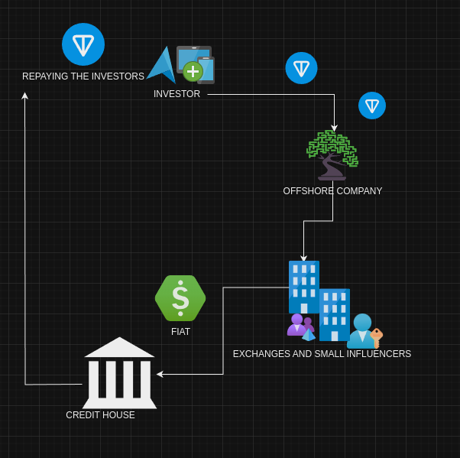

Developed by Marcos Paulo de Oliveira Annibale.
annibalebea@gmail.com
marcos@annibale.me
+55 (19) 9 8313-5034
TG: memanibale


​

